**Ticket Booking System**

It is a web-based event management system that allows users to book, cancel, and view seat availability in real time. It uses a Python Flask backend to handle API requests and a clean HTML and JavaScript frontend for user interaction. When a user reserves seats, the system updates the available seats in a local JSON file. The summary section displays total seats, available seats, and reservation count. This project shows how APIs, JSON storage, and frontend forms work together to manage event tickets efficiently and accurately.

Outputs:

Web page:

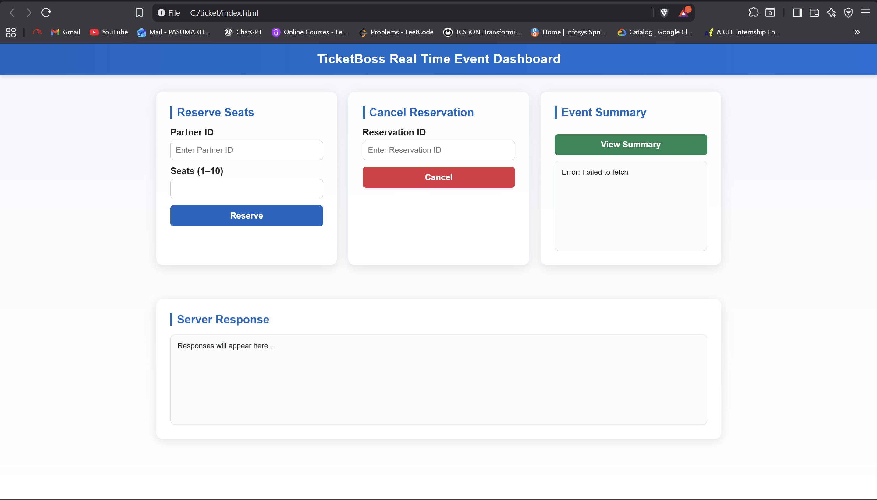

Initial Json storage:

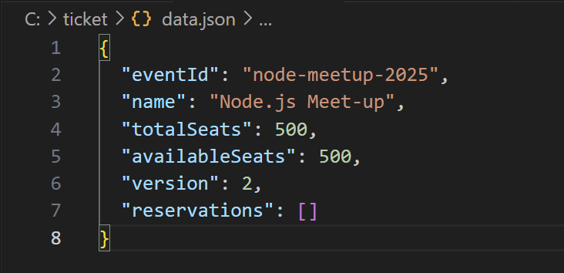

Json storage after booking a ticket:

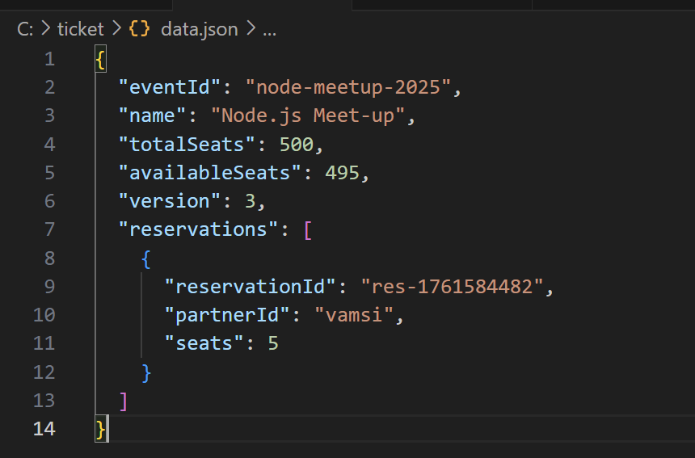

Outputs of web page:

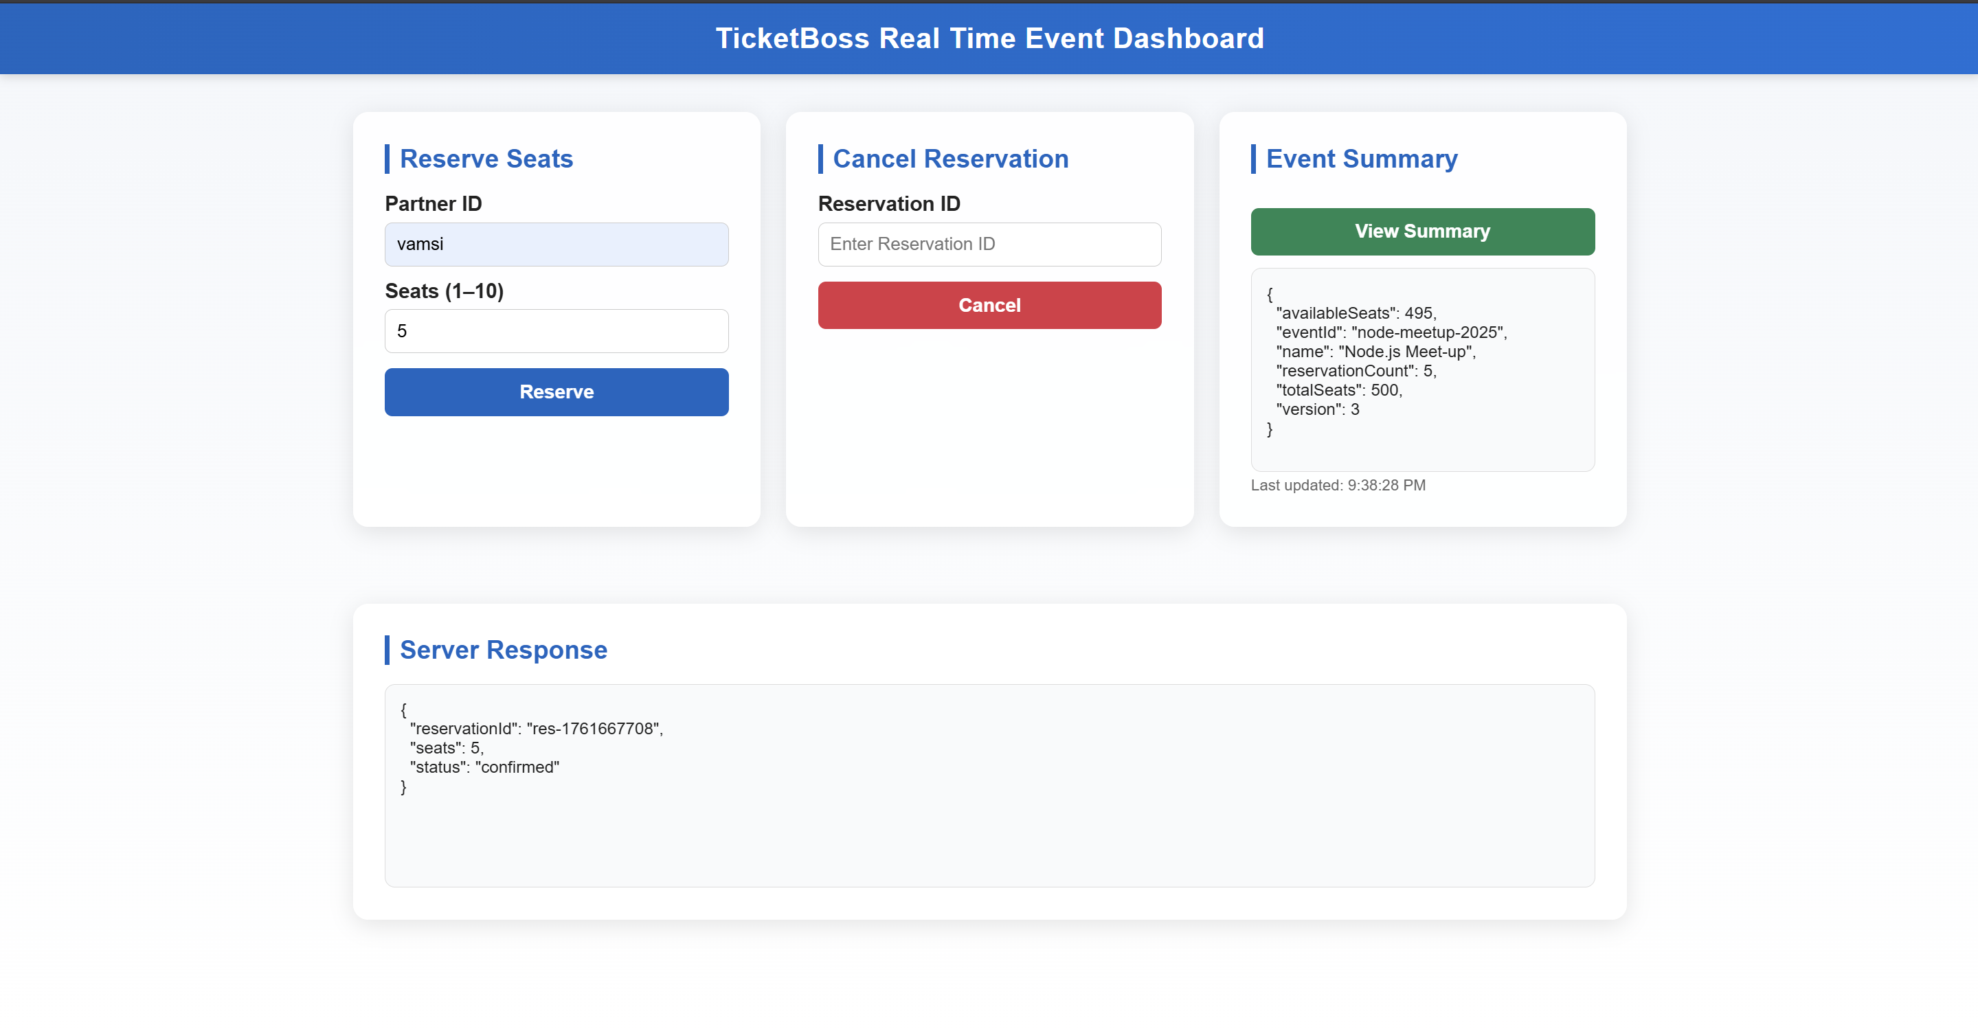

Another reservation:

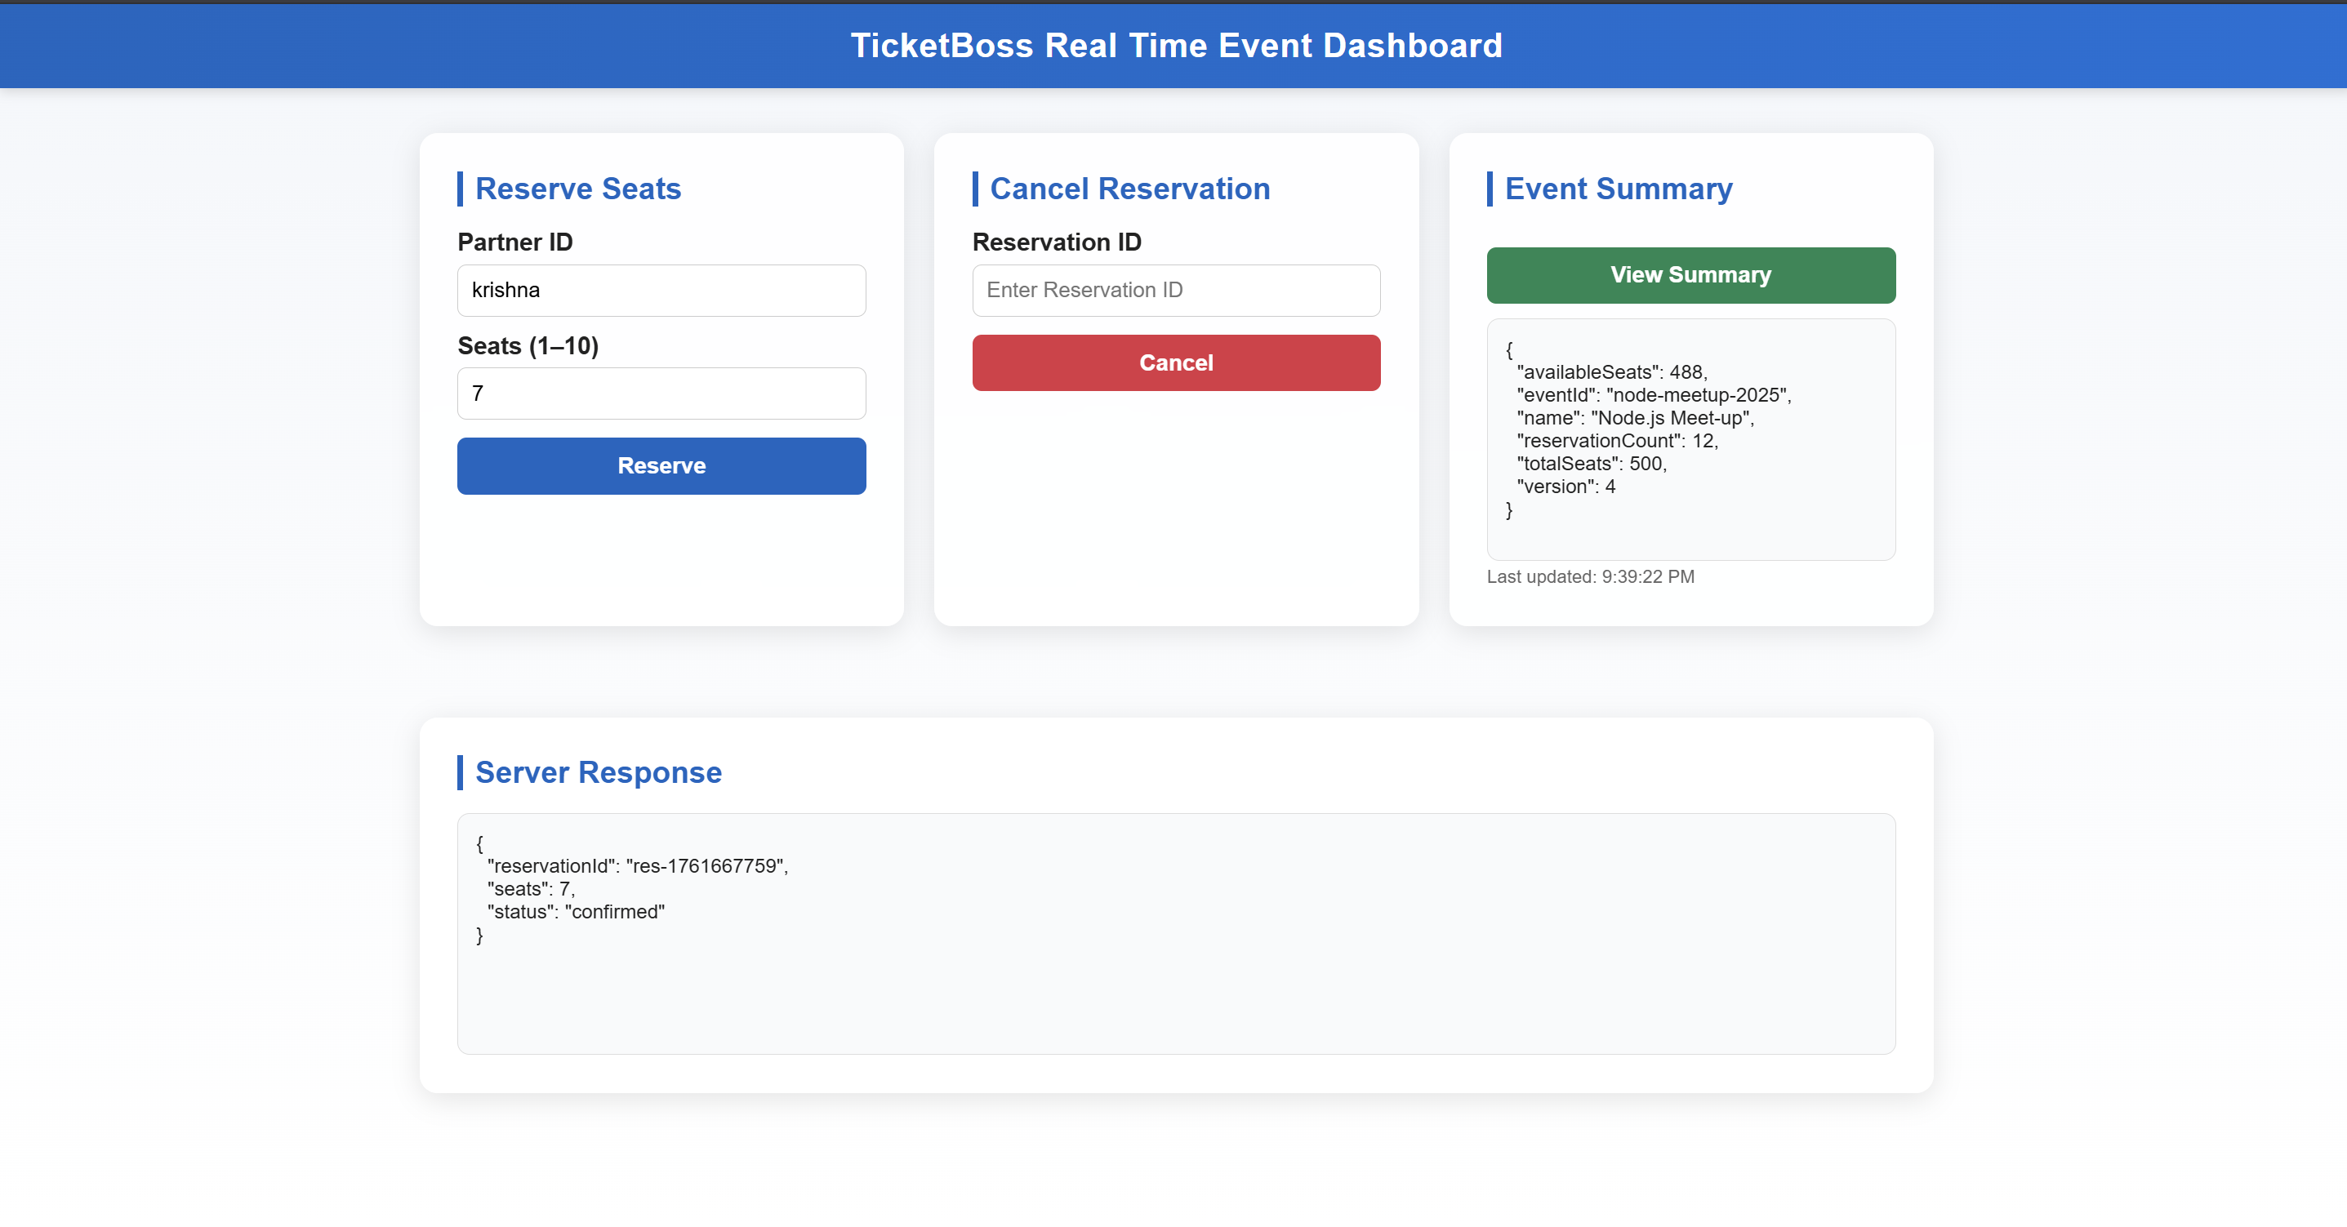

Json storage:

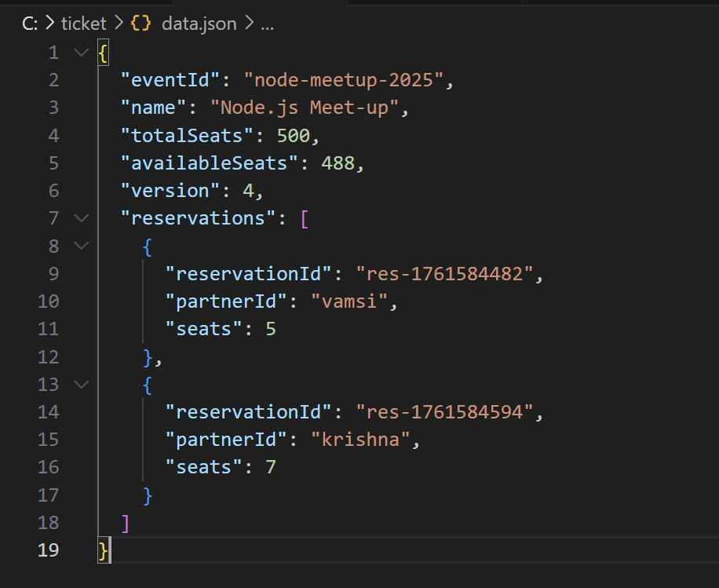  
flask calls:

